INDIA AIR QUALITY ANALYTICS-2026

1. Project Overview
This project focuses on analyzing air quality data to identify pollution trends, pollutant distribution, and regional pollution patterns across different cities and states. The analysis helps understand environmental conditions and supports data-driven decision-making for pollution control and public health improvement.
What is the project about?
The project involves analyzing air quality datasets to evaluate pollution levels, pollutant types, and pollution concentration across locations.
What problem are you solving?
Identifying highly polluted regions, major contributing pollutants, and pollution variations that affect environmental and public health conditions.
Why is this analysis important?
This analysis helps environmental authorities and organizations monitor air quality, identify pollution hotspots, and improve pollution management strategies.

2. Objectives
The key goals of this project are:
• Identify highly polluted and low-polluted cities based on average pollution levels using city-wise analysis.
• Analyze the contribution of pollutant types such as PM10, PM2.5, OZONE, CO, NO2, SO2, and NH3 to overall air pollution.
• Compare average pollution levels across different states to identify highly affected regions.
• Detect geographical pollution hotspot regions using state-wise pollution map visualization.
• Compare minimum and maximum pollution levels for each pollutant type to analyze pollution variation.
• Rank monitoring stations based on pollution severity to identify critical pollution locations across states.
• Analyze AQI category distribution using category-wise record counts to understand overall air quality conditions.
Support environmental decision-making using data insights

3. Data Sources
- Dataset Source: Government / Air Quality API Dataset
- Timeline: 2026
- Data Size: Approximately 3.4K records and 12 columns
- Tools Used: Excel, Power Query, Power BI
4. Attribute (Column / Features) Details
Attribute Name | Data Type | Description
country | Categorical (Text) | Represents the country where the pollution station is located.
state | Categorical (Text) | Represents the state name of the monitoring location.
city | Categorical (Text) | Represents the city where pollution data was recorded.
station | Categorical (Text) | Represents the pollution monitoring station name.
Last update | Date | Indicates the latest date when pollution data was updated.
latitude | Decimal Number | Represents the latitude coordinate of the monitoring station.
longitude | Decimal Number | Represents the longitude coordinate of the monitoring station.
Pollutant id | Categorical (Text) | Represents pollutant types such as PM10, PM2.5, NO2, CO, etc.
Pollutant min | Whole Number | Represents the minimum pollution value for the pollutant.
Pollutant max | Whole Number | Represents the maximum pollution value for the pollutant.
Pollutant avg | Whole Number | Represents the average pollution value for the pollutant.
AQI Category | Categorical (Text) | Represents AQI levels such as Good, Moderate, and Hazardous.

5. Data Cleaning (Preprocessing)
The following preprocessing steps were performed to ensure data quality and consistency:
- Cleaned and transformed data using Excel Power Query
- Changed incorrect data types into appropriate formats
- Removed duplicate and unnecessary records
- Deleted state names from the station column because the information already existed in the state column
- Renamed columns for better readability and understanding
- Handled missing values using AverageIFS imputation method
- Created a new calculated column named AQI Category using the SWITCH() DAX function to classify pollution levels into categories such as Good, Moderate, Unhealthy, Very Unhealthy, and Hazardous based on average pollution values.
- Verified and standardized dataset structure for accurate analysis

Data Modeling
- The dataset used for this dashboard contains a denormalized table structure, where all related data attributes are stored within a single consolidated table. Therefore, complex data modeling, table relationships, and schema creation were not required for this analysis.
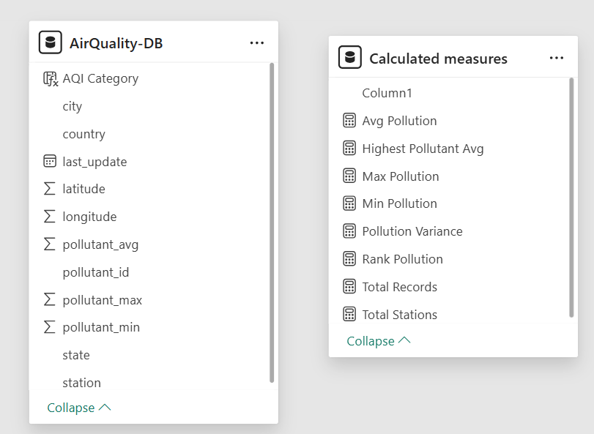
6. Exploratory Data Analysis (EDA) & Visualization
- Performed statistical analysis on air quality data
- Conducted city-wise, state-wise, and pollutant-wise analysis
- Analyzed minimum, maximum, average, and variance pollution levels
- Built interactive dashboards and visualizations using Power BI
- Used map visualization to identify pollution hotspot regions
- Added interactive navigation buttons for switching between Table View and Visual View dashboards.
Features Included:
- Interactive dashboard with 3 slicers (City, State, Pollutant Type) and a “Clear All Slicers” option for dynamic data filtering and quick filter reset.
- Interactive visuals and cross-filtering
- Pollution ranking visualization
- KPI cards for pollution metrics
- Geographical map-based analysis
- Interactive navigation buttons for switching between Table View and Visual View

7. SMART Framework in Insights
- Specific: Identify highly polluted cities, states, and dominant pollutant types using air quality data.
- Measurable: Measure pollution levels using KPIs such as Average Pollution (44.32), Maximum Pollution (500), Highest Pollution (341), and Pollution Variance (499).
- Achievable: Build an interactive Power BI dashboard with slicers, maps, charts, and pollution ranking analysis.
- Relevant: Support environmental monitoring and help identify pollution hotspots for better environmental decision-making.
- Time-Bound: Analyze and monitor air quality trends for the year 2026 using pollution data insights.

8.Dashboard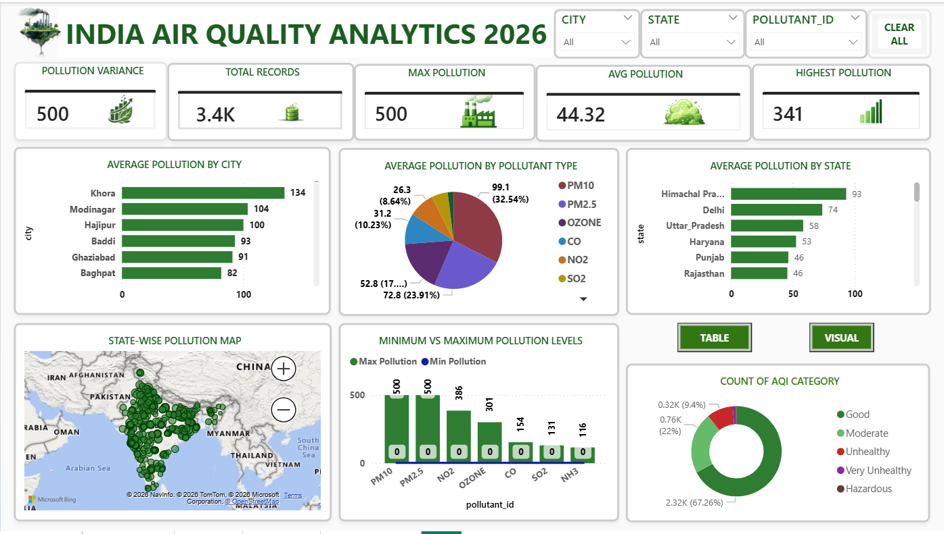
India Air Quality Analytics-2026 dashboard
9.Key Insights
Insights Based on the Average Pollution by City Chart
1. Descriptive Analytics – What Happened?
- Khora recorded the highest average pollution level with 134.
- Modinagar (104) and Hajipur (100) were the next highly polluted cities.
- Cities such as Chhal and Thrissur recorded the lowest pollution levels with values close to 0.

2. Diagnostic Analytics – Why Did It Happen?
- Higher pollution levels in Khora and Modinagar may be due to industrial activities and vehicle emissions.
- Urban population growth and traffic congestion contributed to increased pollution concentration.
- Lower pollution levels in Chhal and Thrissur may indicate better environmental conditions and lower industrial emissions.

3. Predictive Analytics – What Might Happen Next?
- Highly polluted cities may experience further increases in pollution levels if preventive measures are not implemented.
- PM10 and other particulate pollutants may continue affecting urban regions.
- Low-pollution cities may remain under safer AQI categories if current conditions are maintained.

4. Prescriptive Analytics – What Should Be Done?
- Implement stricter pollution control measures in highly polluted cities like Khora and Modinagar.
- Increase pollution monitoring and environmental awareness programs.
- Promote green transportation and sustainable environmental practices to reduce pollution levels

Insights Based on the Average Pollution by Pollutant Type Chart
1. Descriptive Analytics – What Happened?
- PM10 recorded the highest average pollution level with 99.1 (32.54%).
- PM2.5 was the second highest pollutant with 72.8 (23.91%), followed by OZONE with approximately 52.8.
- CO recorded an average pollution value of 31.2 (10.23%), while NO2 contributed 26.3 (8.64%).
- SO2 showed the lowest pollution contribution with an average value of 16.44 (5.4%).

2. Diagnostic Analytics – Why Did It Happen?
- Higher PM10 and PM2.5 levels may be caused by industrial emissions, vehicle smoke, road dust, and construction activities.
- OZONE, CO, and NO2 pollution may increase due to urban traffic congestion and environmental reactions in the atmosphere.
- Lower SO2 contribution may indicate comparatively controlled sulfur-related industrial emissions.

3. Predictive Analytics – What Might Happen Next?
- PM10 and PM2.5 are likely to remain dominant pollutants if industrial and transportation emissions continue increasing.
- Urban regions may experience higher air quality deterioration due to increasing particulate matter concentration.
- Pollutants such as NO2 and OZONE may gradually increase in highly urbanized areas.

4. Prescriptive Analytics – What Should Be Done?
- Implement stricter emission control measures for industries and vehicles to reduce PM10 and PM2.5 levels.
- Increase air quality monitoring in urban and industrial regions.
- Promote sustainable transportation and environmental protection initiatives to control pollutant concentration levels.
Insights Based on the Average Pollution by State Chart
1. Descriptive Analytics – What Happened?
- Himachal Pradesh recorded the highest average pollution level with 93, followed by Delhi (74) and Uttar Pradesh (58).
- Haryana recorded an average pollution level of 53, while Punjab and Rajasthan showed similar pollution levels of 46.
- Nagaland recorded the lowest pollution level with 7, while Meghalaya and Arunachal Pradesh showed lower pollution levels of approximately 15.

2. Diagnostic Analytics – Why Did It Happen?
- Higher pollution levels in Himachal Pradesh, Delhi, and Uttar Pradesh may be due to urbanization, industrial activities, and vehicle emissions.
- Northern states showed higher pollution concentration because of increasing transportation and environmental factors.
- Lower pollution levels in Nagaland, Meghalaya, and Arunachal Pradesh may indicate lower industrial density and better environmental conditions.

3. Predictive Analytics – What Might Happen Next?
- Highly polluted states may continue experiencing worsening air quality if pollution control measures are not strengthened.
- Urban and industrial regions may face increasing pollution levels due to population growth and transportation activities.
- States currently showing lower pollution levels may maintain safer AQI conditions if environmental practices are preserved.

4. Prescriptive Analytics – What Should Be Done?
- Strengthen pollution monitoring and emission control policies in highly polluted states such as Himachal Pradesh and Delhi.
- Promote green transportation and sustainable environmental initiatives to reduce pollution levels.
- Increase environmental awareness and maintain ecological protection measures in low-pollution states.
Insights Based on the State-Wise Pollution Map
1. Descriptive Analytics – What Happened?
- The pollution map shows higher pollution concentration across northern and central regions of India.
- Multiple pollution hotspot locations were identified in densely populated and urbanized areas.
- Southern and northeastern regions showed comparatively fewer pollution concentration points.

2. Diagnostic Analytics – Why Did It Happen?
- Higher pollution concentration in northern regions may be due to industrial activities, urbanization, and vehicle emissions.
- Dense pollution clusters indicate areas with increased population density and transportation activities.
- Lower pollution concentration in some regions may indicate better environmental conditions and lower industrial emissions.

3. Predictive Analytics – What Might Happen Next?
- Pollution hotspot regions may experience further air quality deterioration if preventive measures are not implemented.
- Urban and industrial regions are likely to continue showing higher pollution concentration levels.
- Regions with lower pollution density may maintain safer AQI conditions if current environmental practices continue.

4. Prescriptive Analytics – What Should Be Done?
- Strengthen pollution monitoring systems in highly concentrated pollution hotspot regions.
- Implement stricter industrial and vehicle emission control measures.
- Promote sustainable environmental practices, green transportation, and pollution awareness programs across highly affected areas.
Insights Based on the Minimum vs Maximum Pollution Levels Chart
1. Descriptive Analytics – What Happened?
- PM10 and PM2.5 recorded the highest maximum pollution levels with values of 500 each.
- NO2 showed a maximum pollution level of 386, followed by OZONE with 301.
- CO (154), SO2 (131), and NH3 (116) recorded comparatively lower maximum pollution levels.
- Minimum pollution values for all pollutants were recorded close to 0.

2. Diagnostic Analytics – Why Did It Happen?
- Higher PM10 and PM2.5 levels may be caused by industrial emissions, road dust, and vehicle pollution.
- NO2 and OZONE pollution may increase due to traffic congestion and atmospheric chemical reactions.
- Lower minimum values indicate pollution fluctuations across different locations and time periods.

3. Predictive Analytics – What Might Happen Next?
- PM10 and PM2.5 may continue remaining the most dominant pollutants if emission levels increase further.
- Urban and industrial regions may experience higher air quality deterioration over time.
- Pollution fluctuations may continue across regions due to environmental and seasonal changes.

4. Prescriptive Analytics – What Should Be Done?
- Implement stricter emission control measures for industries and transportation sectors.
- Increase air quality monitoring systems for highly affected pollutants such as PM10 and PM2.5.
- Promote sustainable environmental practices and pollution reduction initiatives to control pollution levels.
Insights Based on the AQI Category Count Chart
1. Descriptive Analytics – What Happened?
- The Good AQI category recorded the highest count with approximately 2.32K records.
- The Moderate category recorded around 0.76K records, while the Unhealthy category showed approximately 0.32K records.
- Very Unhealthy and Hazardous categories recorded the lowest counts with approximately 41 and 5 records respectively.

2. Diagnostic Analytics – Why Did It Happen?
- Higher Good AQI records indicate that most locations maintained comparatively safer air quality conditions.
- Moderate and Unhealthy AQI categories may be influenced by urbanization, industrial emissions, and transportation activities.
- Lower counts in Very Unhealthy and Hazardous categories suggest that extremely severe pollution conditions occurred less frequently.

3. Predictive Analytics – What Might Happen Next?
- If environmental conditions remain stable, most regions may continue staying under the Good AQI category.
- Increasing industrialization and vehicle emissions may gradually increase Moderate and Unhealthy AQI records.
- Hazardous AQI conditions may rise in highly urbanized regions if pollution control measures are not strengthened.

4. Prescriptive Analytics – What Should Be Done?
- Continue maintaining pollution control measures to preserve Good AQI conditions across regions.
- Strengthen air quality monitoring systems in Moderate and Unhealthy AQI regions.
- Promote sustainable transportation, industrial emission control, and environmental awareness initiatives to prevent hazardous pollution conditions.

Insights Based on the Station-Wise Pollution Ranking Chart
1. Descriptive Analytics – What Happened?
- Prashant Garden - UPPCB recorded the highest station-wise average pollution level with 134, followed by Ved Vihar-Loni (115.43) and MIET College (115.00).
- Several highly polluted stations were located in Uttar Pradesh, indicating higher pollution concentration in the region.
- Stations such as Corporation Ground - Kerala PCB and Nawapara SECL Colony - CECB recorded pollution levels close to 0.

2. Diagnostic Analytics – Why Did It Happen?
- Higher pollution levels in stations from Uttar Pradesh may be due to industrial activities, vehicle emissions, and urbanization.
- Dense population and transportation activities may have contributed to increased pollution concentration in highly ranked stations.
- Lower pollution levels in stations from Kerala and Chhattisgarh may indicate comparatively better environmental conditions.

3. Predictive Analytics – What Might Happen Next?
- Highly polluted stations may continue experiencing poor air quality if pollution control measures are not strengthened.
- Urban and industrial monitoring stations are likely to show increasing pollution trends over time.
- Low-pollution stations may remain under safer AQI categories if current environmental conditions continue.

4. Prescriptive Analytics – What Should Be Done?
- Strengthen pollution monitoring and emission control measures in highly polluted stations and urban regions.
- Promote green transportation and industrial pollution control initiatives.
- Increase environmental awareness and sustainable practices to reduce pollution concentration levels.
10. Conclusion
This Air Quality Analysis project successfully identified pollution trends, highly polluted regions, and major contributing pollutants using data analytics techniques. The project demonstrates how data visualization and analytical insights can support environmental monitoring and help authorities make better pollution control decisions

